Summer 2022

MOUNT LOFTY BOTANIC GARDEN WALK FROM THE UPPER CAR PARK

To help keep visitors keep COVID-19 safe we provide a copy on the Noticeboard at the Garden that may be photographed to take with you or there is a downloadable version on our website (https://www.friendsbgadelaide.com/guided-walks)
________________________________________________________________________________________________________

This summer trail is a pleasant walk aiming to be a cool interlude on even the hottest day. Before leaving the carpark, there is a wonderful display of daylily or Hemerocallis along the lower bank. The flowers of these perennial plants, whose name originates from the Greek words for ‘day’ and ‘beautiful’, generally open at sunrise and wither at sunset, to be replaced by another flower on the same stalk the next day. They are native to Eurasia, but now popular worldwide with over 60,000 registered cultivars.

On the corner of the road leading down from the car park, the curious leaves of tulip tree, Liriodendron tulipifera can be seen, with many flowers which can be enjoyed through December. A member of the Magnolia family, they are pollinated by insects and bees, though they do not flower until about 20 years old. Those growing in the lower car park flower profusely in December. The Salvia bed on the right has been heavily pruned this year, and we anticipate flowering through the summer with the attendant honey-eaters enjoying the bounty.

Along the road on the left is a hedge of Daphne x transatlantica ‘Eternal Fragrance’ which was only introduced to the Garden a few years ago. Just before the track takes a sharp turn left, there is a selection of the tulip tree mentioned above on your right. This one is Liriodendron tulipifera “Aureomarginatum”. This one is a selection, termed a cultivar, chosen because it features a yellow margin to all its leaves. In this cultivar, the yellow area of the leaf does not produce chlorophyll and, as a result this cultivar tends to be smaller than its cousins.

Keep to the bitumen road and veer left then take the small bitumen path on the right to make a short detour down to western allspice, Calycanthus occidentalis which has complex red flowers with reflex petals which will be followed by interesting pods. The oldest known member of the genus that has found its way into gardens, C. florida, which Mark Catesby noted (1732) in the woodlands of Piedmont Carolina; he described it, with its bark "as odoriferous as cinnamon" but did not name it. The planters of Carolina gathered it into their gardens, and Peter Collinson imported it into England from Charleston, South Carolina about 1756; he described it to Linnaeus.

On return to the bitumen road the Ilex or holly collection will be on your right, showing variations in leaf colour and many berries. In winter these may be red or yellow. A delightful story from “Hollies” by H. Harold Hume, published in 1953 notes that
“somewhere in the dim past, the pagans of Europe brought into their dwellings sprays of native holly so that tiny, fairy, friendly peoples of the forest might find refuge in them from the frigid blasts of winter. The thought was a kindly one, and so the use of holly in interior decorations began.”
It was the early Christians of Rome who first used holly as decoration in their Christmas season, and it has featured since then in superstition, legend, folklore, songs and stories. One interesting selection in this collection is an Ilex aquifolium ‘Argenteo marginata’. This may sound like a mouthful, but all it means is “holly, needle leaf, silver edges”- which is a surprisingly good description of this variegated common holly, native to western Europe.

Take the road to the right of the summerhouse, where you will glimpse through the trees Greg Johns’ ‘Guardian Figure’” set out on the lawn. On the left the tall, straight trunks of stringybark, Eucalyptus obliqua grow well in this dry environment, while a little further on note the serrated edges of the leaves on Viburnum dentatum. The flower heads will develop bright berries in the winter. Along the first path on the left we find an attractive Berberis with variegated leaves, followed by winged spindle tree, Euonymous alatus. The name becomes obvious when examining the branches as it comes from the Latin for winged. In north-eastern USA it is known as “burning bush” for its vibrant autumn colour but has become an invasive plant and is banned in Massachusetts.

Take the steps down to the road and turn left through the native bushland. On the left about 50m along you will find the wayfaring tree, Viburnum lantana, a native of Europe, Africa and Asia. An older name is “hoarwithy”. “Hoar” means grey-haired and refers to the hairs under the leaves, and “withy” means a pliant stem.

At the seat take a sharp right for a short detour where on the right-hand side is a Chinese quinine, Dichroa febrifuga, an evergreen member of the hydrangea family. This specimen flowers profusely throughout the summer followed by bright blue berries in the winter. This is an important herb in traditional Chinese medicine as an antimalarial, where it is considered one of the 50 fundamental herbs; ‘febrifuga’ means ‘fever banishing’. Nearby is a Chinese anise, Illicium lanceolatum showing red flowers. Return to the seat and take the path on the right leading across the hill face. On the left there are several katsura, Cercidiphylum japonicum with soft, heart-shaped leaves making a cool display for a hot day. In autumn the tree has a delicious burnt-toffee aroma from the brilliantly coloured leaves.

On the right of the path, and a little down the slope Rhododendron basilicum has very large leathery leaves with a downy fawn indumentum on the underside, the new growth being very upright. Nearby is a conifer, Calocedrus macrolepis from Burma and China has soft foliage, and the stems have an interesting zig-zag appearance. The bushland on the right has heavy foliage and many fallen tree trunks which offer a habitat for lizards and butterflies and no doubt refuge for the small native animals.

After passing another Greg Johns’ sculpture, ‘Between Earth and Sky’, take the path on the left where on the right are several interesting snakebark maples, Acer rubescens. These specimens are distinguished by markings on smooth bark, red leaf stalks/petioles, and racemes of small, winged fruits termed samaras. At the road turn left and walk beside Stan’s Wall. On the left of the road is a collection of Viburnum spp. which are now towards the end of flowering but are setting many berries for a colourful autumn and winter display. Take the path up through the camellias to return to the car park.
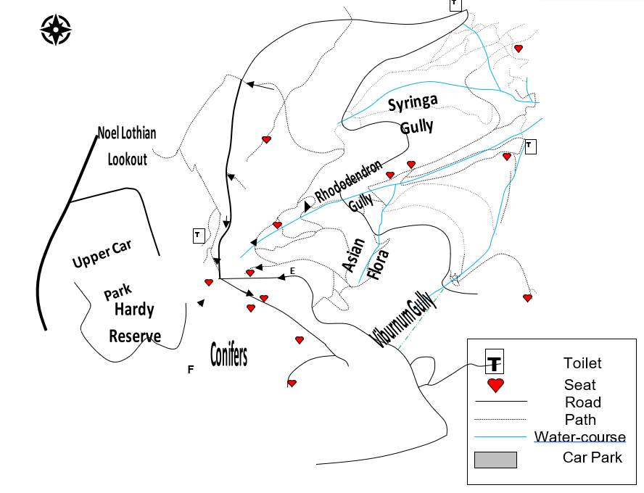
MD, HM, RH and NF 2021

This leaflet has been prepared by the Garden Guides and funded by the Friends of the Botanic Gardens of Adelaide Inc.
For information about the Friends and/or guided walks, please telephone 8222 9367
www.friendsbgadelaide.com.au

