APRIL 2021 WALK FROM THE LOWER CAR PARK

To help keep visitors keep COVID-19 safe we have decided that, rather than supply a
paper copy of the walk, there is a downloadable version on our website (https://www.friendsbgadelaide.com/guided-walks) or a copy in the Noticeboard at the
Garden that may be photographed to take with you. The map at the end of this walk is
an enlarged section of the general map of the garden showing the location of this month’s plants.

The deciduous plants at Mount Lofty Botanic Garden (MLBG) are developing vibrant autumn colours as cold autumn nights prevail. Hopefully, there will be rain soon to help plants retain their leaves. The green colour in most plants is related to their chlorophyll content. Chlorophyll is a biomolecule which is essential to photosynthesis as it allows plants to absorb light energy and convert it into a food source for plants. The green colour occurs as chlorophyll molecules strongly absorb energy from the blue and red portions of the light spectrum whilst reflecting green light. As deciduous trees prepare for winter, their leaves cease to function, which includes loss of chlorophyll. As the chlorophyll level declines other natural pigments in the leaf become visible. Yellow is the default colour for most plants. However, there are many species which contain pigments which provide contrasting colours, including shades of red and orange. Further some plants also produce pigments which add to the colour that appears as chlorophyll activity declines. Over time, gardeners have selected plants for their autumn display and the MLBG has a wonderful collection providing a stunning vista.
On the northern side of the Car Park, make your way down the path to the right of the Quercus robur or English oak. The bed on the right contains many brightly coloured perennial plants, including Rudbeckia hirta ‘Indian Summer’. Commonly called black-eyed Susan, these large yellow members of the daisy family Asteraceae, have a prominent black centre, and flower from early summer to late autumn. They are native to the prairies of mid-western USA and need rich well-drained soil and lots of sunshine to grow well. The plant was named by Carolus Linnaeus the Swedish botanist, zoologist and physician, who is the father of modern taxonomy due to his work on a systematic classification of living things. Linnaeus named the plant after his patron Professor Olof Rudbeck of Uppsala University and he used the Latin word “hirta” (meaning hairy) as the species name.
As the path descends adjacent to the Lower Car Park, a planting of Betula nigra or river birch on your left is showing some characteristic features of this species. Look up the dark grey trunk where you can see the papery red-brown bark starting to peel. Buttery yellow diamond-shaped leaves fall from this deciduous tree during autumn. Native to central and eastern United States of America, this tree thrives in wet soils.
Make your way across the small bridge into the wet Arboretum. To your right and gleaming in the light and standing out amongst the green of surrounding foliage is Ulmus carpinifolia ‘variegata’, a tall tree with leaves densely mottled with white, giving a silvery-grey look. This member of the Elm family with small leaves is classified as a smooth-leaved elm and appears to be related to Ulmus minor, the field elm, whose natural range is south European extending to Asia Minor and Iran and north to the Baltic Islands. These species have been naturalised in the UK for many years. The useful timber is close-grained and water resistant and is used for water pipes, wheels, keels, mallets, parts of wagons, furniture, coffins, and numerous other large and small items.
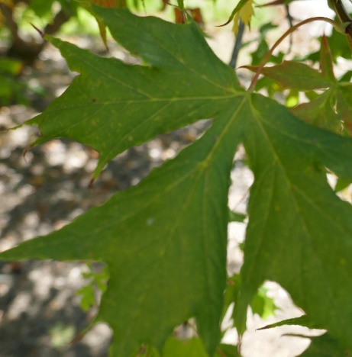
Continue along the path through the Arboretum and up the hill with the “Aceratum” on your right. This is a collection of Acer species which provide a stunning display of a range colours during autumn. A typical specimen is Acer platanoides ‘Dissectum’, a selection of the Norway maple. This selection has leaves with five veins/lobes although close inspection will show variation from three to seven divisions with varying depths of separation between lobes. Another feature of Acers is their development of paired samaras, which are fruit which contain seeds and have formed flattened papery wings which allow the seeds to be dispersed widely through a “helicopter” action, particularly in breezy weather.

Follow the path to the right to the dam wall and admire the Ampelopsis brevipedunculata (with a short flower stalk) or porcelain berry, which will have bright turquoise, blue and mauve berries into winter. This vine is a member of the family Vitaceae, which includes all wine grapes Further on is a highly coloured vine, Vitis coignetiae. The vine is native to Asia and is named after a couple named Coignet who enjoyed the plant on a trip to Japan in 1875 so much that they took seeds back to France. On their return, it was evaluated as a Phylloxera resistant stock, which was valued as the Phylloxera vine aphid had devastated French wine production.
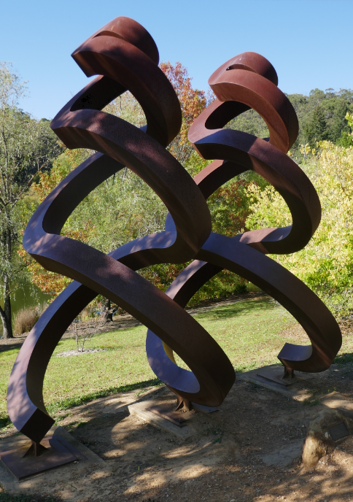
Make your way along the path to the Duck Pond. Just after the path to the right is dwarf specimen of Taxodium distichum ‘Pendulum’, a selection of the swamp bald cyprus. This specimen is grafted to a standard rootstock trunk, resulting in a pleasing weeping appearance. This specimen has a one-metre-tall trunk and MLBG staff take particular care in keeping the tree free of suckers, as the vigor of the rootstock will rapidly take over from the graft if suckers are not professionally managed. Take a moment to look back towards the Main Lake, where there are three full sized Taxodium distichum, clearly showing the contrast with the dwarf selection. Note that these are deciduous conifers, and their needles will turn an orange-brown colour before being shed for winter. Follow the path up to the pin oaks, Quercus palustris. These trees are native to the eastern United States. Note the upright branches at the top of the tree and the downward pointing ones at the bottom, which help shed snow when falls are heavy. Look back at the Taxodium distichum ‘Pendulum’ and note the extensive pendulous growth which has developed in the eight years since this specimen was established.
Continue along the path where there are several maples (Acer spp) that have been selected for their spectacular foliage. Acer platanoides ‘Crimson Sentry’ is a compact upright tree with large crimson leaves which turn to orange and gold in autumn. Nearby is Acer palmatum ‘Shaina’, another Japanese maple selection. Its five-pointed, narrow lobed leaves are bright red in spring, deepening to a rich crimson red in summer. In autumn, the leaves turn back to red for a stunning autumn display. Nearby is Acer palmatum ‘Orangeola’, another member of the “Dissectum” group. This selection has a weeping form and is slow growing. Its new foliage in spring is bright red which turns to a bronze and green colour during summer. In autumn, as the name suggests, the foliage turns a brilliant orange.
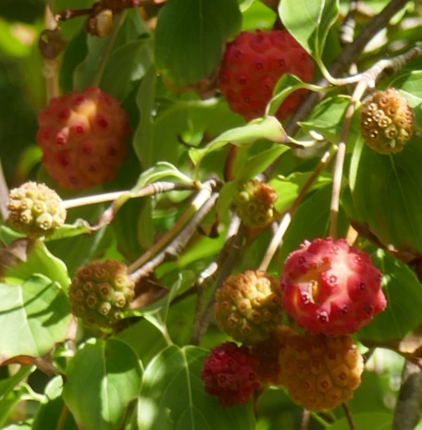
A little further up on the right is another maple, Acer japonicum ‘Vitifolium’. Note the five lobed leaves, with serrated edges which look very much like vine leaves, hence the “vitifolium” name of the selection. A little further on and up to the right is another maple selection, Acer palmatum ‘Pixie’. Note the contrast between the youngest growth which is pink and the red of the old foliage. On the corner of the path where we head down to the back of the Duck Pond, is a beautiful swathe of Cyclamen hederifolium, the ivy-leaved cyclamen, “hedera” from the Latin for ivy, and ‘folium” meaning leaf. It is the most widespread cyclamen species and is the most widely cultivated after the florist's cyclamen (Cyclamen persicum). It is a tuberous perennial that blooms and sprouts leaves in autumn, grows through the winter, and goes dormant before summer, when the seed pods ripen and open. The leaf colour varies from all green to all silver but the most common is a Christmas tree of hastate (like a spear head) pattern.
Just as you begin to cross the walkway, and on your left, there is a weeping cedar, Cedrus deodora ‘Waverley Ridge’. This cedar is a local hills selection from the nearby area of Waverly Ridge at Crafers. Whilst crossing the stepping stones, the weeping willow, Salix caprea ‘Pendula’ makes a pleasing backdrop to the pond This shaded area of the garden has some beautiful autumn colour in the mollis azalea plantings. These were originally from Japan where many hybrids of Rhododendron japonicum were selected. Taking pride of place in this area is a Cornus kousa or kousa dogwood. This specimen has a large crop of fruit, something not often seen by the Guides on this site. The fruit can be used to make a wine. These berries complement the attributes that make this dogwood an excellent ornamental specimen with showy blooms in spring and a rich red autumn foliage.
We hope that you have enjoyed this walk and gained appreciation of some of the delights the MLBG offers during autumn. We recommend you continue around the Lake, on your way back to the Car Park. If you have time, try exploring one of the gullies on the right of the road, each with different themed collections.
TA, EB, MD, BF, JH, HM (All photographs), DS, RH and NF 4/21

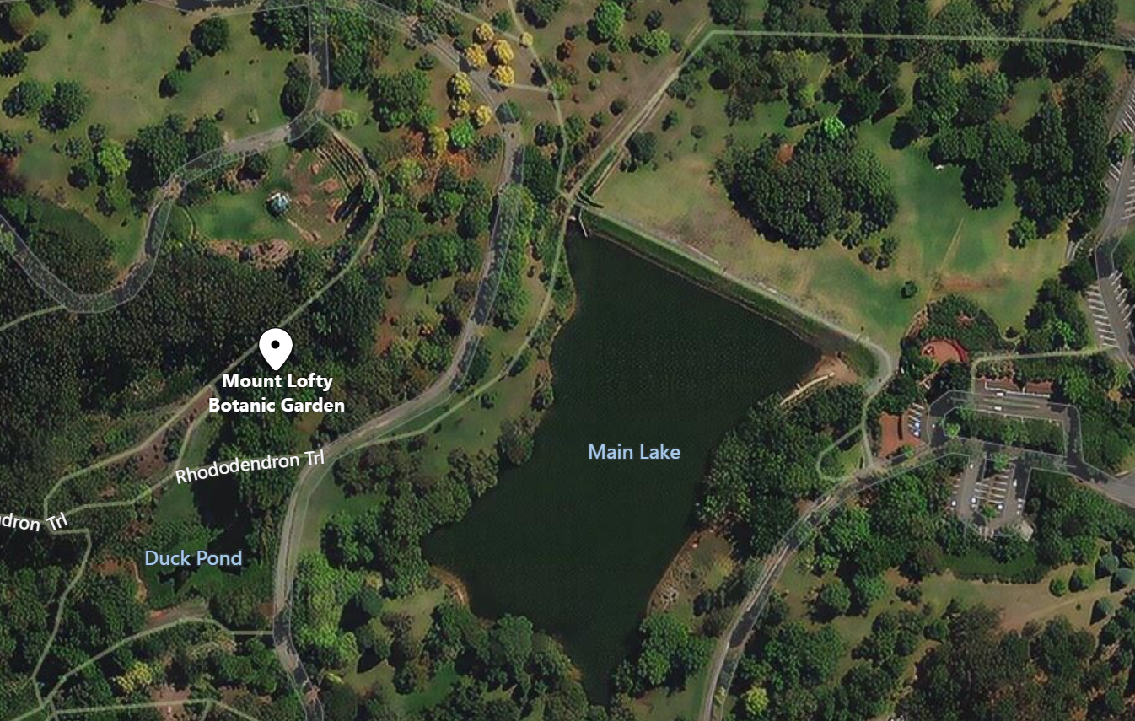

This leaflet has been prepared by the Garden Guides and funded by the Friends of the Botanic Gardens of Adelaide
For information about the Friends and/or guided walks, please telephone 8222 9367.
www.friendsbgadelaide.com.au

